**IFT 466 Advanced Computer Networks**

**Lab 10  
EIGRP – Troubleshooting**

**Note:** You will need Packet Tracer Version 7 or above to complete this lab

**Objective**Troubleshoot a network topology using the various commands that you have learned throughout this course, identify the incorrect configuration, update this configuration and successfully get two PCs to ping each other.

Upload the packet tracer file “EIGRP_Troubleshooting_I”

**Problem**

R1 is not able to ping R4 – work out why not

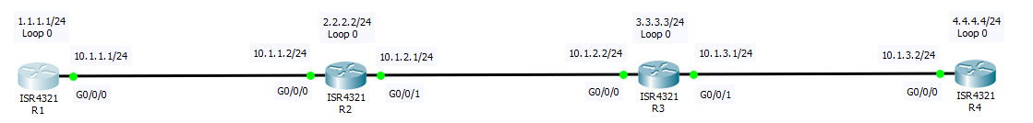

**Solution**

What was your process for troubleshooting this problem?  
What show commands did you use help you resolve the and why did you use these command?

**Solution:**

I started by pinging each router from R1 and observed that ping to 10.1.2.1 is not working from R1. So, I verified below show commands in R2.

First, in R2 I had verified the neighbors and observed that network 10.1.2.2 is not added as a neighbor under process 100. So, I have created neighbors In R3 and verified again.

In R3, I added both of its neighbors using EIGRP process 100. And verified using show ip route command.

Similarly, I have updated the neighbors in R4 and verified the connections using the show IP route command in all the routers.

Now I tried to ping from R1 to R4 and it is successful.

Finally, verified by ping all he networks from R1.

